Upload in github successfully

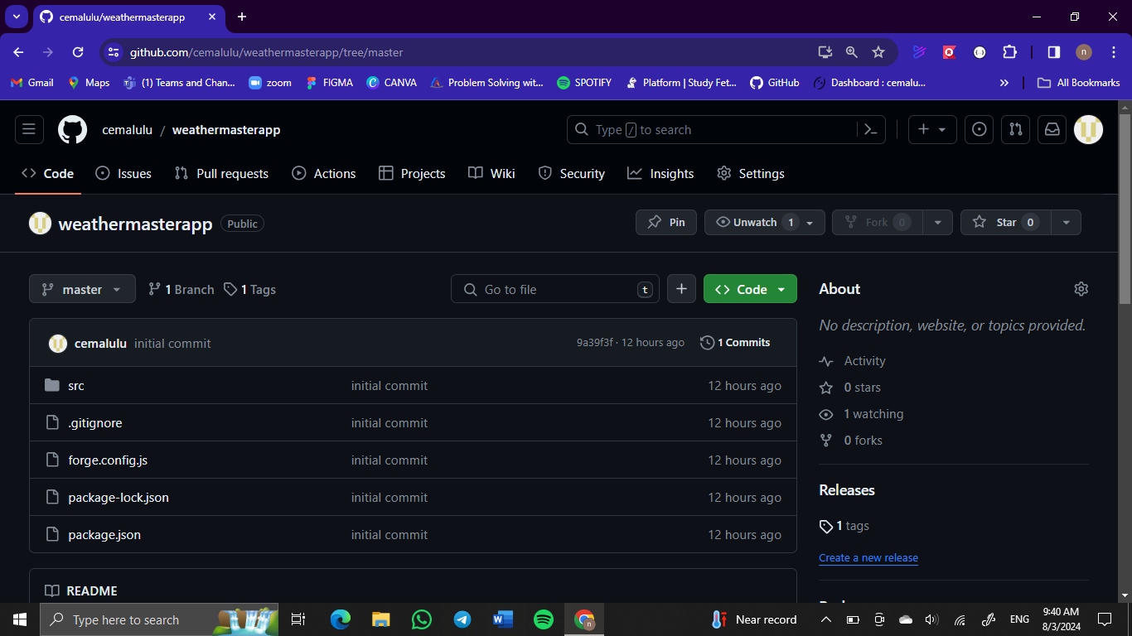

The link to the github:

<https://github.com/cemalulu/weathermasterapp.git>